School Counseling Program Newsletter
Shandrai Silva, School Counselor | April 2019

Counselor Message  Happy April! This month, we will continue to explore college and careers. Students are excited about these lessons and are especially looking forward to Career Day on April 17th.  How to see the school counselor  Classroom guidance classes are weekly based on grade level specials schedule. Small group counseling and individual counseling by self-referral, parent referral, teacher referral, administrator or counselor initiated.  This month, we are recognizing GCS  Mental Health Awareness Week on  April 8th – 12th. During Mental Health  Awareness, we will focus on taking care of our mental and emotional health.  As we approach the end of the school year, students are encouraged to keep working hard and to do their best always.  GCS Mental Health Awareness Week  April 8th -12th  You Matter!  - Remember your positive qualities and accomplishments.  -Engage in healthy hobbies and exercise.  -Set realistic goals.  -Smile often.  -Think positive thoughts.  -Compliment yourself and others. | Home of the Hawks      HNSA Career Day  Wednesday, April 17, 2019  *Wear College Tshirt or as what you  want to be when you grow up- no costumes for non career-related attire.  April is Child Abuse Prevention Month  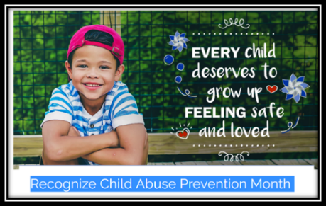https://www.preventchildabusenc.org/get-involved/recognize-child-abuse-prevention-month  http://preventchildabuse.org/  April is Autism Awareness Month   | Character Education  “We’re Soaring with Good Character”  _____________________________  The character trait of the month is Honesty. Honesty means being truthful in what you say and do.  ________________________________  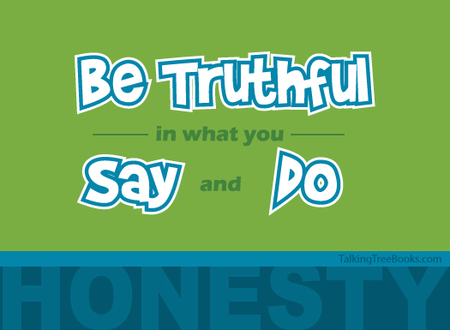  "Be honest in what you say and what  you do." -Talking with Trees Books  Tips for Encouraging Honesty for Families  - Encourage Honesty- explain what it means to be honest and why it‘s an important value. Reflect on times of dishonesty and the impact of the dishonesty.  - Model Honesty - Pay close attention to whether you are modeling honesty and integrity in your day to day interactions.  - Praise Honesty- When a child lies, remind them it is wrong to lie but, also important to thank children when they are honest and willing to share.  https://mcc.gse.harvard.edu/resources-for-families/tips-encouraging-honesty  “Intelligence plus character- that is the goal of true education.”  Dr. Martin L. King, Jr.
https://www.autismspeaks.org/get-involved

